1

# Class Quiz 4

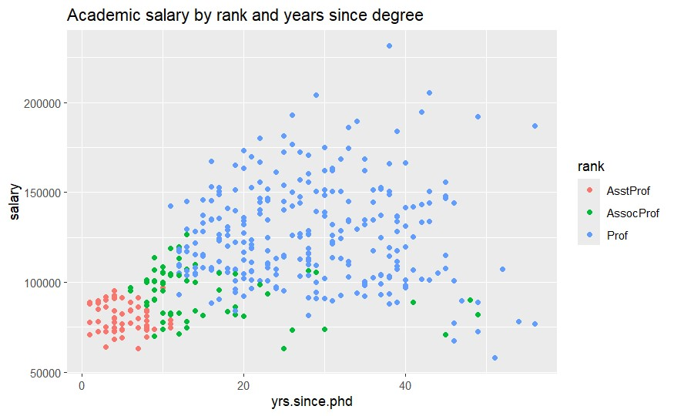

# Career Progression & Salary Growth

• Career growth is structured, as academic members continue to advance from assistant professor to associate professor to full professor, resulting in compensation increases. Although there seems to be diversity among ranks, the number of years after a PhD and pay have a substantial positive link. Academic salaries are influenced by rank and experience level, and they typically rise in tandem. Nonetheless, there are distinctions due to factors including administrative responsibilities, research funding, and discipline. Because academics have greater earning potential, assistant professors make less money than professors.